**HEMVATI NANDAN BAHUGUNA GARHWAL UNIVERSITY**

(A Central University)

Srinagar Garhwal, Uttarakhand

School of Engineering and Technology



Session (2020 - 2021)

A PROJECT REPORT ON

**“Shopping Cart Management System”**

Bachelor of Technology

in Computer Science and Engineering

HNBGU, Srinagar Garhwal (Uttarakhand)

**Guided By :- Submitted By:-**

Dr. Prem Nath Swayam

Associate Professor B.Tech (CSE) - IV Sem

Dept. of Computer Science and Engineering Roll No. - 20134501038

**DECLARATION**

**I Swayam** bearing the roll no **20134501038**, student of Computer Science and Engineering Department at Hemvati Nandan Bahuguna Garhwal University (A Central University), Srinagar (Garhwal), Uttarakhand, submit this project report entitled “**Shopping Cart Management System**” to Computer Science and Engineering Department, Hemvati Nandan Bahuguna Garhwal University, for the award of the **Bachelors of Technology degree in Computer Science & Engineering** and declaring that the work done is genuine and produced under the guidance of **Dr. Prem Nath.** Department of Computer Science and Engineering, Hemvati Nandan Bahuguna Garhwal University.

I further declare that the reported work in this project has not been submitted and will not be submitted, either in part or in full, for the award of any other degree in this institute or any other institute or university.

**Student name**

**DATE: 22-08-2022**

**PLACE: Srinagar**

**Swayam**

**CERTIFICATE**

This is to certify that, this project report titled “**Shopping Cart Management System**” submitted by **Swayam** bearing roll no **20134501038** is bonafide record of the work carried out us in partial fulfilment for the requirement of the award of **Bachelor of Technology** in **Computer Science and Engineering** degree from Hemvati Nandan Bahuguna Garhwal University (A Central University) at Srinagar (Garhwal), Uttarakhand.

**Dr. Prem Nath**

**Associate Professor**

Department of Computer Science & Engineering

Hemvati Nandan Bahuguna Garhwal University (A Central University)

Srinagar (Garhwal), Uttarakhand

**ACKNOWLEDGEMENT**

We would like to express my deepest gratitude to all people for sprinkling their help and kindness in the completion of this Project. I would like to start this moment by invoking my purest gratitude to **Dr. Prem Nath**, Department of Computer Hemwati Nandan Bahuguna Garhwal University (A Central University), Srinagar (Garhwal), Uttarakhand, my project instructor.

The completion of this project could not have been possible without his expertise and invaluable guidance in every phase at Hemvati Nandan Bahuguna Garhwal University (A Central University), Srinagar (Garhwal), Uttarakhand for helping me.

We would like to thank **Prof. M.M.S Rauthan, Prof. Y.P Raiwani,** all the lab assistants and other staffs of Computer Science and Engineering Department, Hemvati Nandan Bahuguna Garhwal University (A Central University), Srinagar (Garhwal), Uttarakhand, for their kind support. Last but not least, I would like to thank my parents and my friends for their unwavering belief despite ups and downs in my journey.

**ABSTRACT**

Shopping Cart Management System is developed using basic of C++ programming language and different variables, strings have been used for development of it.

This project is based on the concept of choosing desired products from the list and generating total bill amount.

This project provides the simplest system for management of shopping cart. What’s more, it also minimizes the chances of human error. The program also comes with a lot of impressive features like User will able to purchase Mobiles, Laptops, Watches and also able to choose items after that getting total bill.

**CONTENTS**

**CANDIDATE’S DECLARATION……………………………………………………… i**

**CERTIFICATE………………………………………………………………………….. ii**

**ACKNOWLEDGEMENT………………………………………………………………. iii**

**ABSTRACT ……………………………………………………………………………… iv**

**1. CHAPTER 1: INTRODUCTION…………………………………………………… 6**

**2. CHAPTER 2: ABOUT THE TECHONOLOGY…………………………………. 7-15**

2.1 INTRODUCTION TO C++…………………………………………………. 7-8

2.2 DEV C++……………………………………………………………………. 9

2.3 FEATURES OF C++…………………………………………………… 10-15

**3. CHAPTER 3: S/W H/W REQUIREMENTS……………………………………… 16**

3.1 SOFTWARE REQUIRED…………………………………………………… 16

3.2 HARDWARE REQUIRED…………………………………………………… 16

3.3OPERATING SYSTEM………………………………………………………... 16

**4.CHAPTER 4: ADVANTAGES AND DISADVANTAGES OF C++ 17-22**

4.1 ADVANTAGES OF C++…………………………………….………….. 17-19

4.2 DISADVANTAGES OF C++………………………………………..….. 20-21

4.3 ALTERNATIVES……………………………………………………..….. 22

**5. CHAPTER 5: PROJECT DEMONSTRATION………………………………... 23-27**

5.1 FLOW DIAGRAM……………………………………………………… 28

**6. CHAPTER 6: SOURCE CODE…………………………………………………. 29-49**

**CONCLUSION……………………………………………………………………… 50**

**REFERENCES……………………………………………………………………… 51**

**BIBLIORAPHY…………………………………………………… 52**

**INTRODUCTION**

Shopping management cart is developed using basic of C++ programming language without using graphics. Different variables, functions, strings have been used for development of it. This project is based on the concept of choosing desired products and generating total bill amount. There is no login system in this mini project. User can make an order by selecting from the main menu.

**OBJECTIVE**

The key objective to support the aims are:

* The objective of the shopping management system is to increase the point of customer choice.
* Reduce time used in shopping.
* Efficiency in buying products.
* To develop an easy to use interface.
* To reduce large amount of paper work.
* To make system more flexible.

**CHAPTER 2: ABOUT THE TECHONOLOGY**

**INTODUCTION TO C++**

C++ is a general-purpose programming language that was developed as an enhancement of the C language to include object-oriented paradigm. It is an imperative and a compiled language.

C++ is a middle-level language rendering it the advantage of programming low-level (drivers, kernels) and even higher-level applications (games, GUI, desktop apps etc.). The basic syntax and code structure of both C and C++ are the same.

Some of the features & key-points to note about the programming language are as follows:

* **Simple:** It is a simple language in the sense that programs can be broken down into logical units and parts, has a rich library support and a variety of data-types.
* **Machine Independent but Platform Dependent:** A C++ executable is not platform-independent (compiled programs on Linux won’t run on Windows), however they are machine independent.
* **Mid-level language:** It is a mid-level language as we can do both systems-programming (drivers, kernels, networking etc.) and build large-scale user applications (Media Players, Photoshop, Game Engines etc.)
* **Rich library support:** Has a rich library support (Both standard ~ built-in data structures, algorithms etc.) as well 3rd party libraries (e.g. Boost libraries) for fast and rapid development.
* **Speed of execution:** C++ programs excel in execution speed. Since, it is a compiled language, and also hugely procedural. Newer languages have extra in-built default features such as garbage-collection, dynamic typing etc. which slow the execution of the program overall. Since there is no additional processing overhead like this in C++, it is blazing fast.
* **Pointer and direct Memory-Access:** C++ provides pointer support which aids users to directly manipulate storage address. This helps in doing low-level programming (where one might need to have explicit control on the storage of variables).
* **Object-Oriented**: One of the strongest points of the language which sets it apart from C. Object-Oriented support helps C++ to make maintainable and extensible programs. i.e. Large-scale applications can be built. Procedural code becomes difficult to maintain as code-size grows.
* **Compiled Language**: C++ is a compiled language, contributing to its speed.

**Applications of C++:**

C++ finds varied usage in applications such as:

* Operating Systems & Systems Programming. E.g. *Linux-based OS (Ubuntu etc.)*
* Browsers *(Chrome & Firefox)*
* Graphics & Game engines *(Photoshop, Blender, Unreal-Engine)*
* Database Engines *(MySQL, MongoDB, Redis etc.)*
* Cloud/Distributed Systems

**Some interesting facts about C++:**

Here are some awesome facts about C++ that may interest you:

* The name of C++ signifies the evolutionary nature of the changes from C. “++” is the C increment operator.
* C++ is one of the predominant languages for the development of all kind of technical and commercial software.
* C++ introduces Object-Oriented Programming, not present in C. Like other things, C++ supports the four primary features of OOP: encapsulation, polymorphism, abstraction, and inheritance.
* C++ got the OOP features from Simula67 Programming language.
* A function is a minimum requirement for a C++ program to run.(at least main() function)

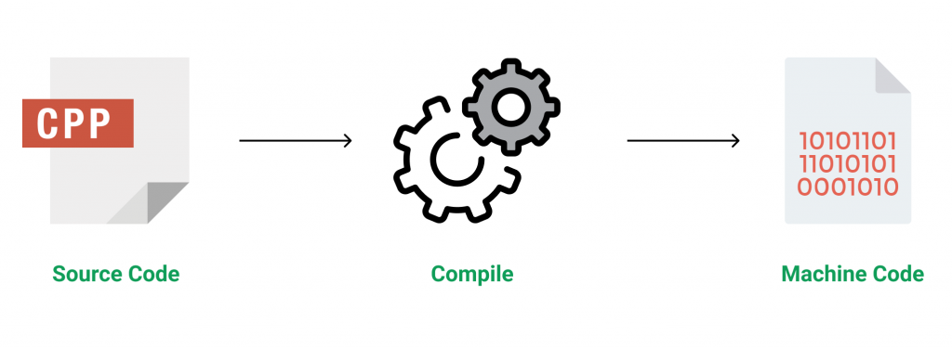

Source- <https://www.geeksforgeeks.org/introduction-to-c-programming-language/>

**Dev C++**

DEV C++ is a complete IDE for the C++ language.

The IDE uses a MinGW port of GCC (GNU Compiler Collection) as its compiler. MinGW is a minimalist approach to write executables for Windows systems. Dev C++ is also usable with Cygwin or any other GCC-based compiler. It was first built in Delphi and was upgraded using Delphi’s latest version.

Millions of users have used Dev C++ since the first version was released back in 1998 by Bloodshed Software. Having been around for over 20 years, the IDE remains a popular learning tool for universities worldwide.

Bloodshed abandoned Dev C++ in 2006 when the team no longer had the time to support it. The software was picked back up in 2010 by Johan Mes, an independent programmer who goes by the name Orwell. After 10 years of working on the IDE, Orwell stepped away from the project. U.S. software company, Embarcadero Technologies, subsequently began sponsoring the IDE and now maintains it.

In addition to being fully functional with C++, Dev C++ also works flawlessly with C. Currently, the Dev C++ IDE is only available on the Windows 7, 8.1 and 10 operating systems.

What Is an IDE?

Integrated development environments like Dev C++ are essential tools that combine a source code editor and a compiler into a single user interface. These software platforms provide programmers and developers with a comprehensive list of tools to develop a software product.

A typical IDE contains a source code editor for writing software. These editors usually feature syntax highlighting for code readability, visual cues and prompts, and auto-completion specific to the language you’re using.

Once a program is written, IDEs can also compile code into an executable program while checking for errors. Programs run within the IDE can be tested for bugs and correct prompts and outputs.

When things don’t go according to plan, IDEs also provide debugging tools to help you locate those pesky errors in your code without you having to scan everything line-by-line. Many IDEs provide hints while coding to prevent errors before the compilation stage.

**FEATURES OF C++**

There are various features of C++ such as,

* Object Oriented
* Simple
* Platform Dependent
* Mid-level programming language
* Structured programming language
* Rich Library
* Memory Management
* Powerful & Fast
* Pointers
* Compiler based
* Syntax based language

Let’s discuss each one of them one by one.

**Object Oriented Programming language**

The main upgradation from C to C++ is object-oriented programming. It follows concept of oops like polymorphism, inheritance, encapsulation, abstraction. This makes development and maintenance easier.

Let’s briefly understand the concepts of object-oriented programming.

* Class: A class is a user-defined blueprint or prototype from which objects are created. It represents the set of properties or methods that are common to all objects of one type.
* Object: It is a basic unit of Object-Oriented Programming and represents the real-life entities. A C++ program creates many objects which interact by invoking methods.
* Polymorphism: Polymorphism refers to the ability of OOPs programming languages to differentiate between entities with the same name efficiently.
* Inheritance: Inheritance is the mechanism in which one class is allowed to inherit the features (fields and methods) of another class.
* Encapsulation: Encapsulation is defined as the wrapping up of data under a single unit. It is the mechanism that binds together code and the data it manipulates.
* Abstraction: Data Abstraction is the property by virtue of which only the essential details are displayed to the user. The trivial or the non-essentials units are not displayed to the user.

**Features of C++ : Simple**

C++ provides a structured approach wherein you can break the problem into parts and design the solution modularly. It provides you a rich set of library functions that you can use while implementing the solution.

If you have worked with C language, then moving to C++ would be a very smooth transitioning. The syntax is almost similar with minute changes.

* **Platform Dependent**

Platform dependent language means the language in which programs can be executed only on that operating system where it is developed & compiled. It cannot run or execute it on any other operating system.

C++ is a platform-dependent language. Having said that, C++ programs can be executed in many machines with little bit or no change.

* **Mid-level programming language**

C++ has the ability to do both low-level & high-level programming. This is the reason why C++ is known as a mid-level programming language. When we talk about low-level programming, C++ is used to develop system applications such as the kernel, driver, etc.

* **Structured programming language**

In C++ programming, the code is modular with the help of functions, classes & objects, and the modules are loosely coupled. Modular code is easy to understand & modify. This makes C++ a structured programming language.

* **Rich Library**

Developers have access to lots of in-built functions provided by C++ language. This saves time & makes development fast. Let’s look at some of the C++ header files & functionalities provided by it.

1. <iostream>: Contains C++ standard input and output functions
2. <iomanip>: Contains stream manipulators that format streams of data
3. <cmath>: Contains math library functions
4. <cstdlib>: Contains function for conversions of numbers to text and vise versa, memory allocation, random numbers and various other utility functions.
5. <ctime>: Contains function for manipulating the time and date
6. <fstream>: Contains function for functions that perform input from files on disk and output to files on disk
7. <memory>: Contains classes and functions used by the C++ Standard Library to allocate memory to the C++ Standard Library containers
8. <iterator>: Contains classes for accessing data in the C++ Standard Library containers
9. <algorithm>: Contains functions for manipulating data in C++ Standard Library containers

* **Memory Management**

C++ supports dynamic memory allocation. You can free the allocated memory at any time. Not only this C++ also provides dynamic memory management techniques.

* **Powerful & Fast**

C++ is a fast language as compilation and execution time is less. Also, it has a wide variety of data types, functions & operators.

* **Pointers**

Pointers are variables that store the address of another variable. Pointer points to the memory location of a variable. C++ supports pointer and provides solutions to lots of problems that demand access to memory location.

* **Compiler based**

C++ is a compiler-based programming language. Without compilation, no C++ program can be executed. The compiler first compiles the C++ program and then it is executed.

* **C++ Features: Syntax based language**

C++ is a language that complies strongly with syntax. Language following rules and regulations very strictly is known as tight syntax-based language. C, C++, Java, .net are some of the examples.

**CHAPTER 3: S/W H/W REQUIREMENTS**

**3.1: Software Requirement**

* Any compiler for C++
* Dev C++ is used in this project

**3.2: Hardware Requirement**

* Processor: x86 or x64
* RAM : 4 GB (minimum), 8 GB (recommended)

**3.3: Operating System**

* Windows 7 , 8, 10 / MAC

**CHAPTER 4: ADVANTAGES AND DISADVANTAGES OF C++**

**ADVANTAGES OF C++**

1. Portability

C++ provides this feature of portability allowing us to develop codes without caring about the hardware. This lets us move the development of a program from one platform to another.

For example, you’re working on Windows OS and for some reason, you have to switch to LINUX, the codes from Windows OS will also run in the LINUX OS without any error.

2. Mid-level programming language

Being a mid-level programming language, we can treat it as both a low-level and high-level language. Features of high-level language help to develop games and desktop applications, whereas features of low-level language help make kernels and drivers.

3. Object-Oriented

The OOP concepts like polymorphism, encapsulation, inheritance, and abstraction give C++ the biggest advantage over other programming languages. It proved to be of great significance since this feature was not in C, this helped users to treat data as objects and classes.

4. Multi-paradigm programming language

Paradigm refers to the planning involved in programming. It concerns the logic, the style, and the way how we proceed with the program. C++ is a multi-paradigm programming language as it follows three paradigms:

a. Generic – Using a single idea that serves multiple purposes.

b. Imperative – Using steps that change the state of the program.

c. Object-Oriented – Using methods and classes for reusability and modularity.

5. Memory Management

C++ supports DMA (Dynamic Memory Allocation), which helps to free and allocate memory. Since there is no garbage collection, C++ gives the programmer total control over memory management.

6. Fast and Powerful

As C++ is a compiler-based programming language; we do not require to install a special runtime while running the program. Hence, they are pre-interpreted and it makes the code faster and more powerful.

Even the compilation and execution are faster allowing it to create several kinds of programs from games to drivers to complicated GUIs.

7. Similar to other languages

C++ syntax is similar to C#, C, and Java. It makes learning C++ easier if you already know one of them. It also makes switching to and from other languages easier.

This can be treated as an added benefit that C++ is compatible with C programs i.e. every running C program can be run as a C++ program. Most of the time we just need to run the program on a file .cpp extension.

8. Standard Library

C++ provides a good range of built-in libraries. They help in making the software development faster and allows the user to do more with less.

9. Wide Range of Applications

C++ is useful to make GUIs as well as games. C++ is also useful to develop graphics and real-time algebraic simulation. Hence, C++ is beneficial in every stream.

10. Huge Community

C++ has a vast community around it. Community size is very important if you want to get supported every now and then. The larger the community size, more the help you’ll get to solve your problems.

A huge number of paid/free online courses and lectures are available, which shows how community support works.

11. Scalability

One of the greatest advantages of C++ is its scalability, i.e. its program can be scaled to another level. Hence, resource-intensive applications can be built using C++, as the programs can be low-scale and high-scale.

12. Big Job Market

As we know that C++ has benefits in various departments from finance to app developments, GUI to Games, C++ has a very big job market. Knowledge of C++ can help you secure a job at such departments where C++ comes in handy.

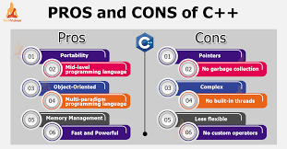

Source- <https://techvidvan.com/tutorials/cpp-pros-and-cons/>

**DISADVANTAGES OF C++**

1. Pointers

When it comes to pointers in C++, it is a very tough conception compared to other topics. Uninitialized pointers might result in system failure.

Memory corruption can also take place if one puts wrong values in the same. To sum up, debugging pointer bugs is very difficult and hence one of the major disadvantages of C++.

2. No garbage collection

C++ doesn’t support garbage collectors, this means that the entire power to manage the data memory goes in the hands of the user. Absence of the same results in redundant data being stored in turn increasing the memory.

3. Unsafe

C++ is unsafe in a strong sense. The presence of pointers, global variables, etc. is the main reason behind these security issues. It means it is possible to corrupt the entire program just by using a part of the memory as an incorrect type.

4. Complex

C++ is a Multi-Paradigm language, i.e. object-oriented programming with runtime polymorphism, templates, and static polymorphism, some support for functional programming. C++ is not useful for platform-dependent apps and hence is complex in a very huge high-level program.

5. Less flexible

C++ is very strict regarding the syntax, a little mishap gives a series of errors. It generally takes more time to excel in C++ than any other programming language. It is not easy to write a C++ code in a readable way, making the language less user-friendly and less flexible for the user.

6. No custom operators

In many programming languages like Java, we can define operators for specific operations. But, in C++ it is not quite possible. We can redefine existing operators using operator overloading, but nothing more.

7. No built-in threads

There’s no support for built-in threads in C++. Even though it is a relatively newer concept it was later added to the newest standard of C++. But it is still far-fetched compared to programming languages like Java.

8. Lack of algebraic data types

Algebraic data types like tuples and structs are not supported in C++. Because of this, we need to use libraries or our own executions if we need to use it.

9. Functions are not first-class type

First-class type functions are those where:

a. Values can be passed and return, without restrictions.

b. Functions can be created and constructed anywhere, without any restrictions.

c. The function can be typed in such a way that an entity can be assigned to it.

**ALTERNATIVES OF C++**

1. **PYTHON**- Python is one of my favorite programming languages. It is an interpreted language. It is very easy to learn. Like C++ Python is also a very powerful language. Nowadays Python is getting used by many programs. Over C++, programmers are using Python which is getting used for its shorter syntax and easy to understand. Machine learning, AI, BigData, Hadoop, automation are some of the places where Python is getting a place over other languages.

2**. JAVA-** Java is a pure object-oriented language as compared to C++. The main difference to choose Java over C++ is that C++ is a platform-dependent language and Java is a platform independent language. First, let me tell you what does this mean. Platform dependent means if you run your code on windows and the same code you are not able to run on other operating systems like Linux. Java uses a compiler plus interpreter to achieve this. C++ uses a compilation step only.

3. **C PROGRAMMING-** C is a subset of C++. C is procedure oriented language. C++ supports object-oriented concepts. C++ is a superset of C programming language.

**CHAPTER 5: PROJECT DEMONSTRATION**

**STEP 1**: Ask for Customer details, For example- the name of customer.

In my code **customerName();** function is constructed for this purpose. We use the getline() function. It is a pre-defined function defined in a **<string.h>** header file used to accept a line or a string from the input stream until the delimiting character is encountered.

**STEP 2:** Ask the user to press S to start shopping.

**STEP 3:** Display menu to the user. **onlineshopping()** function is created for this purpose.

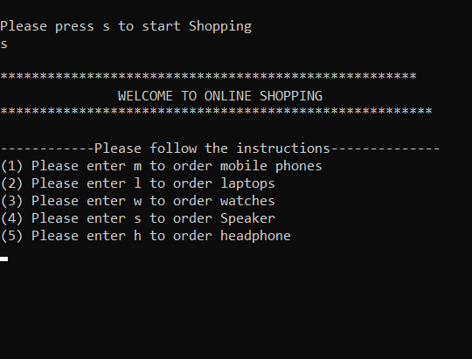

**STEP 4:** Ask the user to enter choice. If user selects m or M then Mobile is selected.

Below are the screenshot shows the mobile menu.

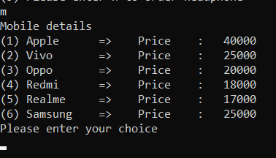

**STEP 5:** Then user will select the item from the menu and choose the quantity.

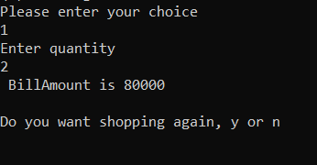

**STEP 6:** Ask the user whether he likes to continue shopping or not.

For this if else statement is used.

If yes, he needs to enter Y/y otherwise to enter N/n.

**STEP 7**: If user press L or l then laptops is selected.

Below are the screenshot shows the laptop menu.

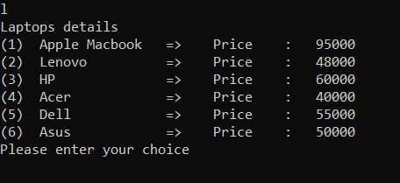

**STEP 8**: If user press W or w then watches is selected.

Below are the screenshot shows the watches menu.

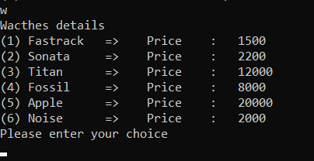

**STEP 9**: If user press S or s then speaker is selected.

Below are the screenshot shows the speaker menu.

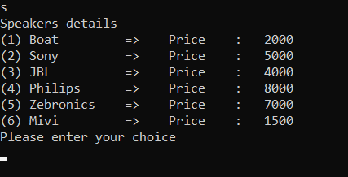

**STEP 10**: If user press H or h then headphones is selected.

Below are the screenshot shows the headphone menu.

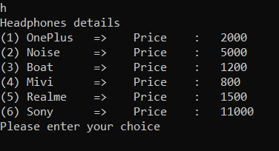

**STEP 11:** If user selects N/n then shopping is terminated and the program displays the CUSTOMER NAME and the TOTAL BILL AMOUNT

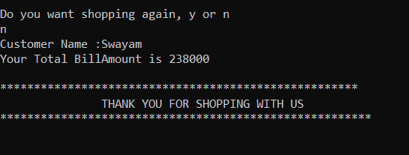

**FLOW CHART**

ENTER CUSTOMER NAME

BRANDS

PRICE

CALCULATES TOTAL BILL

ENTER QUANTITY OF PRODUCTS

CHOOSING ITEMS

DISPLAY LIST OF ITEMS

CUSTOMER SELECTING PRODUCTS

SHOWING LIST OF PRODUCTS

START

ONLINE SHOPPING

**CHAPTER 6: Source code**

#include <iostream>

using namespace std;

int main()

{

char startValue;

string name;

char choiceAgain;

float onlineShopping(void);

void customerName();

{

cout << "Enter your name: ";

getline(cin, name);

cout << " Hello " << name <<endl<<"Welcome to online Shopping" << endl;

}

startLevel:

cout<<endl;

cout << "Please press s to start Shopping" << endl;

start:

cin >> startValue;

if (startValue == 's' || startValue == 'S')

{

float totalAmount = totalAmount + onlineShopping();

cout << " BillAmount is " << totalAmount << endl;

shopAgain:

cout<<endl;

cout << "Do you want shopping again, y or n" << endl;

cin >> choiceAgain;

if (choiceAgain == 'y' || choiceAgain == 'Y')

{

goto startLevel;

}

else if (choiceAgain == 'n' || 'N')

{ cout <<"Customer Name :"<< name << endl;

cout <<"Your Total BillAmount is " << totalAmount << endl;

cout<<endl;

cout << "*****************************************************" << endl;

cout<<" THANK YOU FOR SHOPPING WITH US " <<endl;

cout<<"*******************************************************"<<endl;

cout<<endl; }

else

{

cout << "You have entered wrong option, please type again" << endl;

goto shopAgain;

}

}

else

{

cout << "You have entered wrong option, please type s" << endl;

goto start;

}

}

float onlineShopping()

{

char choice;

char item;

int quantity;

float billAmount = 0;

itemLevel:

cout<<endl;

cout <<"*****************************************************" << endl;

cout<<" WELCOME TO ONLINE SHOPPING " <<endl;

cout<<"*******************************************************"<<endl;

cout<<endl;

cout << "------------Please follow the instructions--------------" << endl;

cout << "(1) Please enter m to order mobile phones" << endl;

cout << "(2) Please enter l to order laptops" << endl;

cout << "(3) Please enter w to order watches" << endl;

cout << "(4) Please enter s to order Speaker" << endl;

cout << "(5) Please enter h to order headphone" << endl;

cin >> choice;

//*******************************Mobile***********************************************

if (choice == 'm' || choice == 'M')

{

mobileLevel:

cout << "Mobile details" << endl;

cout << "(1) Apple => Price : 40000" << endl;

cout << "(2) Vivo => Price : 25000" << endl;

cout << "(3) Oppo => Price : 20000" << endl;

cout << "(4) Redmi => Price : 18000" << endl;

cout << "(5) Realme => Price : 17000" << endl;

cout << "(6) Samsung => Price : 25000" << endl;

cout << "Please enter your choice" << endl;

cin >> item;

if (item == '1')

{

cout << "Enter quantity" << endl;

cin >> quantity;

billAmount = billAmount + quantity * 40000;

}

else if (item == '2')

{

cout << "Enter quantity" << endl;

cin >> quantity;

billAmount = billAmount + quantity * 25000;

}

else if (item == '3')

{

cout << "Enter quantity" << endl;

cin >> quantity;

billAmount = billAmount + quantity * 20000;

}

else if (item == '4')

{

cout << "Enter quantity" << endl;

cin >> quantity;

billAmount = billAmount + quantity * 18000;

}

else if (item == '5')

{

cout << "Enter quantity" << endl;

cin >> quantity;

billAmount = billAmount + quantity * 17000;

}

else if (item == '6')

{

cout << "Enter quantity" << endl;

cin >> quantity;

billAmount = billAmount + quantity * 25000;

}

else

{

cout << "You have entered wrong option, please type again" << endl;

goto mobileLevel;

}

}

//*****************************************Watches********************************

else if (choice == 'w' || choice == 'W')

{

watchesLevel:

cout << "Wacthes details" << endl;

cout << "(1) Fastrack => Price : 1500" << endl;

cout << "(2) Sonata => Price : 2200" << endl;

cout << "(3) Titan => Price : 12000" << endl;

cout << "(4) Fossil => Price : 8000" << endl;

cout << "(5) Apple => Price : 20000" << endl;

cout << "(6) Noise => Price : 2000" << endl;

cout << "Please enter your choice" << endl;

cin >> item;

if (item == '1')

{

cout << "Enter quantity" << endl;

cin >> quantity;

billAmount = billAmount + quantity * 1500;

}

else if (item == '2')

{

cout << "Enter quantity" << endl;

cin >> quantity;

billAmount = billAmount + quantity * 2200;

}

else if (item == '3')

{

cout << "Enter quantity" << endl;

cin >> quantity;

billAmount = billAmount + quantity * 12000;

}

else if (item == '4')

{

cout << "Enter quantity" << endl;

cin >> quantity;

billAmount = billAmount + quantity * 8000;

}

else if (item == '5')

{

cout << "Enter quantity" << endl;

cin >> quantity;

billAmount = billAmount + quantity * 20000;

}

else if (item == '6')

{

cout << "Enter quantity" << endl;

cin >> quantity;

billAmount = billAmount + quantity * 2000;

}

else

{

cout << "You have entered wrong option, please type again" << endl;

goto watchesLevel;

}

}

//******************************************Laptops*******************************

else if (choice == 'l' || choice == 'L')

{

laptopLevel:

cout << "Laptops details" << endl;

cout << "(1) Apple Macbook => Price : 95000" << endl;

cout << "(2) Lenovo => Price : 48000" << endl;

cout << "(3) HP => Price : 60000" << endl;

cout << "(4) Acer => Price : 40000" << endl;

cout << "(5) Dell => Price : 55000" << endl;

cout << "(6) Asus => Price : 50000" << endl;

cout << "Please enter your choice" << endl;

cin >> item;

if (item == '1')

{

cout << "Enter quantity" << endl;

cin >> quantity;

billAmount = billAmount + quantity * 95000;

}

else if (item == '2')

{

cout << "Enter quantity" << endl;

cin >> quantity;

billAmount = billAmount + quantity * 48000;

}

else if (item == '3')

{

cout << "Enter quantity" << endl;

cin >> quantity;

billAmount = billAmount + quantity * 60000;

}

else if (item == '4')

{

cout << "Enter quantity" << endl;

cin >> quantity;

billAmount = billAmount + quantity * 40000;

}

else if (item == '5')

{

cout << "Enter quantity" << endl;

cin >> quantity;

billAmount = billAmount + quantity * 55000;

}

else if (item == '6')

{

cout << "Enter quantity" << endl;

cin >> quantity;

billAmount = billAmount + quantity * 50000;

}

else

{

cout << "You have entered wrong option, please type again" << endl;

goto laptopLevel;

}

}

//***********************************speakers************************************

else if (choice == 's' || choice == 'S')

{

speakerLevel:

cout << "Speakers details" << endl;

cout << "(1) Boat => Price : 2000" << endl;

cout << "(2) Sony => Price : 5000" << endl;

cout << "(3) JBL => Price : 4000" << endl;

cout << "(4) Philips => Price : 8000" << endl;

cout << "(5) Zebronics => Price : 7000" << endl;

cout << "(6) Mivi => Price : 1500" << endl;

cout << "Please enter your choice" << endl;

cin >> item;

if (item == '1')

{

cout << "Enter quantity" << endl;

cin >> quantity;

billAmount = billAmount + quantity * 2000;

}

else if (item == '2')

{

cout << "Enter quantity" << endl;

cin >> quantity;

billAmount = billAmount + quantity * 5000;

}

else if (item == '3')

{

cout << "Enter quantity" << endl;

cin >> quantity;

billAmount = billAmount + quantity * 4000;

}

else if (item == '4')

{

cout << "Enter quantity" << endl;

cin >> quantity;

billAmount = billAmount + quantity * 8000;

}

else if (item == '5')

{

cout << "Enter quantity" << endl;

cin >> quantity;

billAmount = billAmount + quantity * 7000;

}

else if (item == '6')

{

cout << "Enter quantity" << endl;

cin >> quantity;

billAmount = billAmount + quantity * 15000;

}

else

{

cout << "You have entered wrong option, please type again" << endl;

goto speakerLevel;

}

}

//*********************************headphones**************************************

else if (choice == 'h' || choice == 'H')

{

headphoneLevel:

cout << "Headphones details" << endl;

cout << "(1) OnePlus => Price : 2000" << endl;

cout << "(2) Noise => Price : 5000" << endl;

cout << "(3) Boat => Price : 1200" << endl;

cout << "(4) Mivi => Price : 800" << endl;

cout << "(5) Realme => Price : 1500" << endl;

cout << "(6) Sony => Price : 11000" << endl;

cout << "Please enter your choice" << endl;

cin >> item;

if (item == '1')

{

cout << "Enter quantity" << endl;

cin >> quantity;

billAmount = billAmount + quantity * 2000;

}

else if (item == '2')

{

cout << "Enter quantity" << endl;

cin >> quantity;

billAmount = billAmount + quantity * 5000;

}

else if (item == '3')

{

cout << "Enter quantity" << endl;

cin >> quantity;

billAmount = billAmount + quantity * 1200;

}

else if (item == '4')

{

cout << "Enter quantity" << endl;

cin >> quantity;

billAmount = billAmount + quantity * 800;

}

else if (item == '5')

{

cout << "Enter quantity" << endl;

cin >> quantity;

billAmount = billAmount + quantity * 1500;

}

else if (item == '6')

{

cout << "Enter quantity" << endl;

cin >> quantity;

billAmount = billAmount + quantity * 11000;

}

else

{

cout << "You have entered wrong option, please type again" << endl;

goto headphoneLevel;

}

}

else

{

cout << "You have entered wrong option, please type again" << endl;

goto itemLevel;

}

return billAmount;

}

**CONCLUSION**

This report contains the Shopping Cart Management project made using C++ by Swayam CSE Branch submitting for mini project.

* **It helps in eliminating all paper works.**
* **Saves time**
* **Improves customer services**
* **Speed up various processes such as addition of items, calculation of total bills**
* **User friendly**
* **Easy to use**

**REFERENCES**

* [**https://techvidvan.com/tutorials/cpp-pros-and-cons/**](https://techvidvan.com/tutorials/cpp-pros-and-cons/)
* **https://www.lovelycoding.org/online-shopping-system/**
* [**https://www.geeksforgeeks.org/introduction-to-c-programming-language/**](https://www.geeksforgeeks.org/introduction-to-c-programming-language/)
* [**https://www.geeksforgeeks.org/implementing-interactive- online-**](https://www.geeksforgeeks.org/implementing-interactive-%20%20%20%20%20online-)**shopping-in-c/**
* **https://www.interviewbit.com/blog/cpp-projects/**

**BIBLIORAPHY**

In my opinion i have completed my project under the guidance of the esteemed faculty. I thank Dr. Prem Nath Sir who constantly assisting me throughout the project.

Here are some websites to learn about project topic that are given below:

* <https://www.researchgate.net/>
* <https://www.slideshare.net/>
* <https://www.quora.com>